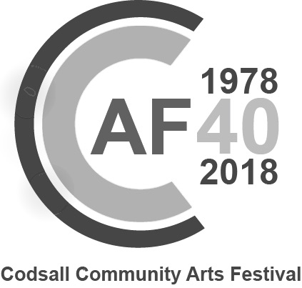
Request for information about becoming a Patron
As at January 2018, the biennial subscription is £15 per household.
Please send me further information about becoming a Patron of Codsall Community Arts Festival Association (CCAFA):
Name ……………………………………………………………………………………….
Address ……………………………………………………………………………………….
……………………………………………………………………………………….
Post Code ……………………………………………………………………………………….
Telephone ………………………………..........................................................
Email address (if any) ……………………………………….........................................
Please return to:
Mrs Janice Sear, 10 Bromley Gardens, Codsall, WOLVERHAMPTON, WV8 1BE,
or email your details to codsallartsfestival@gmail.com
The CCAFA Committee is keen to keep our Patrons informed of all future events, to offer them a period of priority ticket booking, and to have the opportunity to invite existing or new Patrons to pay their subscription in due course. By completing and returning this form, you are giving your consent to the Codsall Community Arts Festival Association holding and using your personal data for these purposes. The Association’s Committee has prepared a “Privacy Notice” which sets out, in detail, all the information that the General Data Protection Regulations (GDPR) require. The full text of the Privacy Notice is available on this website. The essence of the Privacy Notice is to confirm to you that your data will be seen only by members of the CCAFA committee, will be used only for the purposes of the CCAFA, will not be disclosed to any other organisation and will be retained only for as long as current law requires. You remain at liberty to amend your details or withdraw your consent at any time in the future.

